From the Marshall Islands Journal Friday, March 20, 2009

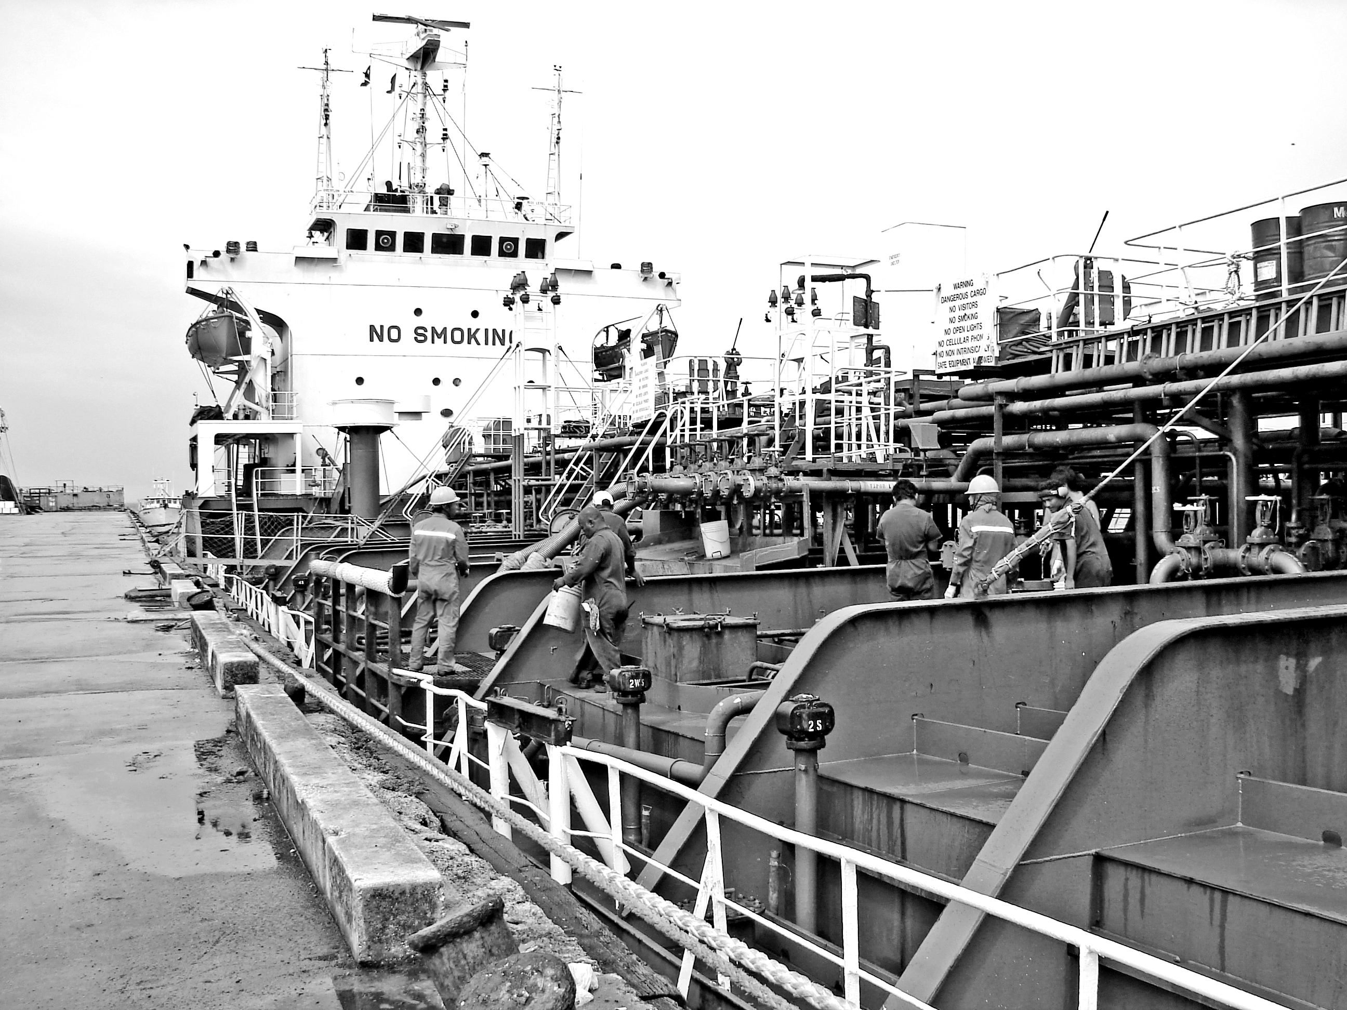

$3 million payment
lets MEC order fuel

The Marshalls Energy Company and the RMI government have paid off $3 million overdue to SK Networks of S. Korea for the last shipment of diesel, and are now gearing to order the next shipment, Chief Secretary and MEC board member Casten Nemra told the Journal Wednesday.
Support from Japan helped solve MEC’s fuel cash crunch.
The government chipped in more than half of that amount, MEC the balance, Nemra said. Despite it being nearly 60-days past the due date for payment when MEC cleared the bill, SK Networks did not hit the RMI with additional fees or interest, Nemra said.
Nemra expressed appreciation to SK Networks for working with the RMI and MEC, and not hitting MEC with additional charges for being late.
MEC officials indicated that an order is being placed for about 2.2 million gallons of diesel to be shipped in mid-April.
MEC reports it still has about a two-month supply of fuel for the power plant as well as sales to fishing vessels.

