From the Marshall Islands Journal Friday, November 17, 2006

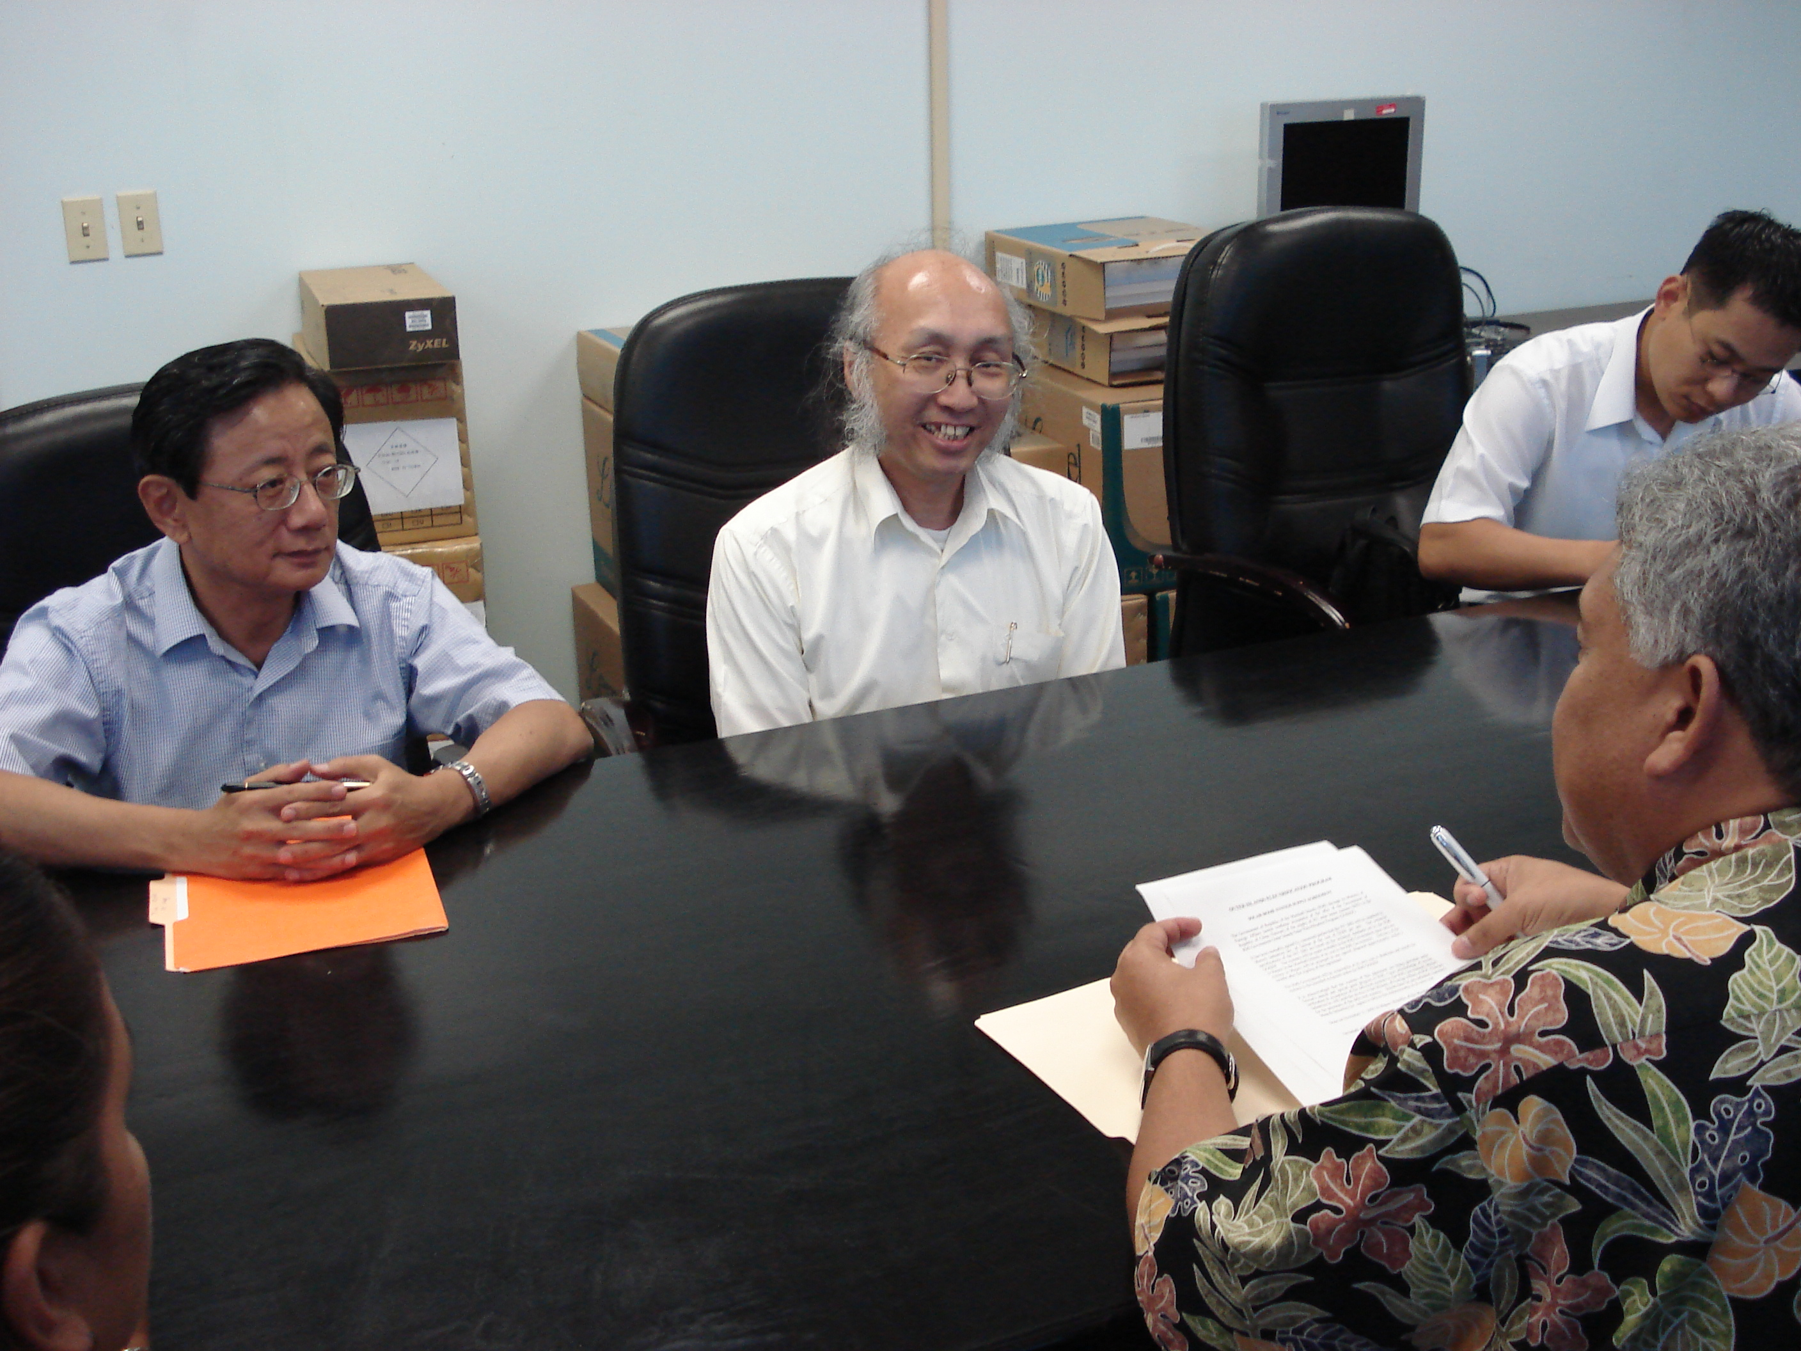

$3m worth of power

A total of 937 solar home systems will be shipped and delivered to the Marshall Islands in about three months following the signing Monday of a supply agreement between Minister Gerald Zackios and Luke Chang, general manager of Motech Industries Inc. of Taiwan.
Ambassador Lien-Gene Chen of the Taiwan Embassy and Attorney General Posesi Bloomfield also witnessed the signing of the supply agreement.
Following a request from the RMI government in April this year, an agreement was reached between the ROC (Taiwan) and RMI governments to implement the Taiwan-RMI solar home system project which is intended to support the development of the residential renewable energy in the outer islands.
Taiwan is funding the project with $3 million — funding that is an advance from its 2006 and 2007 fiscal years, of which $2 million will be advanced in 2006 from the budget support of 2007 Taiwan annual grant and $1 million will be an extra grant disbursed half in 2006 and half in 2007, according to the Embassy.
The agreement provides that 937 solar units will be supplied by Motech Industries Inc . of Taiwan at the cost of $3,200 per unit.
Motech Industries Inc. is one of the most prestigious solar systems makers in the world, renowned for its sophisticated and fine solar products, according to the Taiwan Embassy. President Kessai Note personally visited Motech during his state visit to Taiwan in early April this year and was impressed by its highly advanced and cutting-edge technologies.
The solar home system specifications are based on the technical standards set by the RMI government outer islands solar electrification program (GOISEP). The systems will be made available to the RMI government upon delivery to Majuro in the Marshall Islands at no cost to the RMI government, the Embassy said. The RMI government will be responsible at its own cost to distribute and install the systems to the intended recipients. The Marshalls Energy Company and the Ministry of R&D are in charge of installation and management of the solar systems going into the outer islands.

