From the Marshall Islands Journal Friday, February 9, 2007

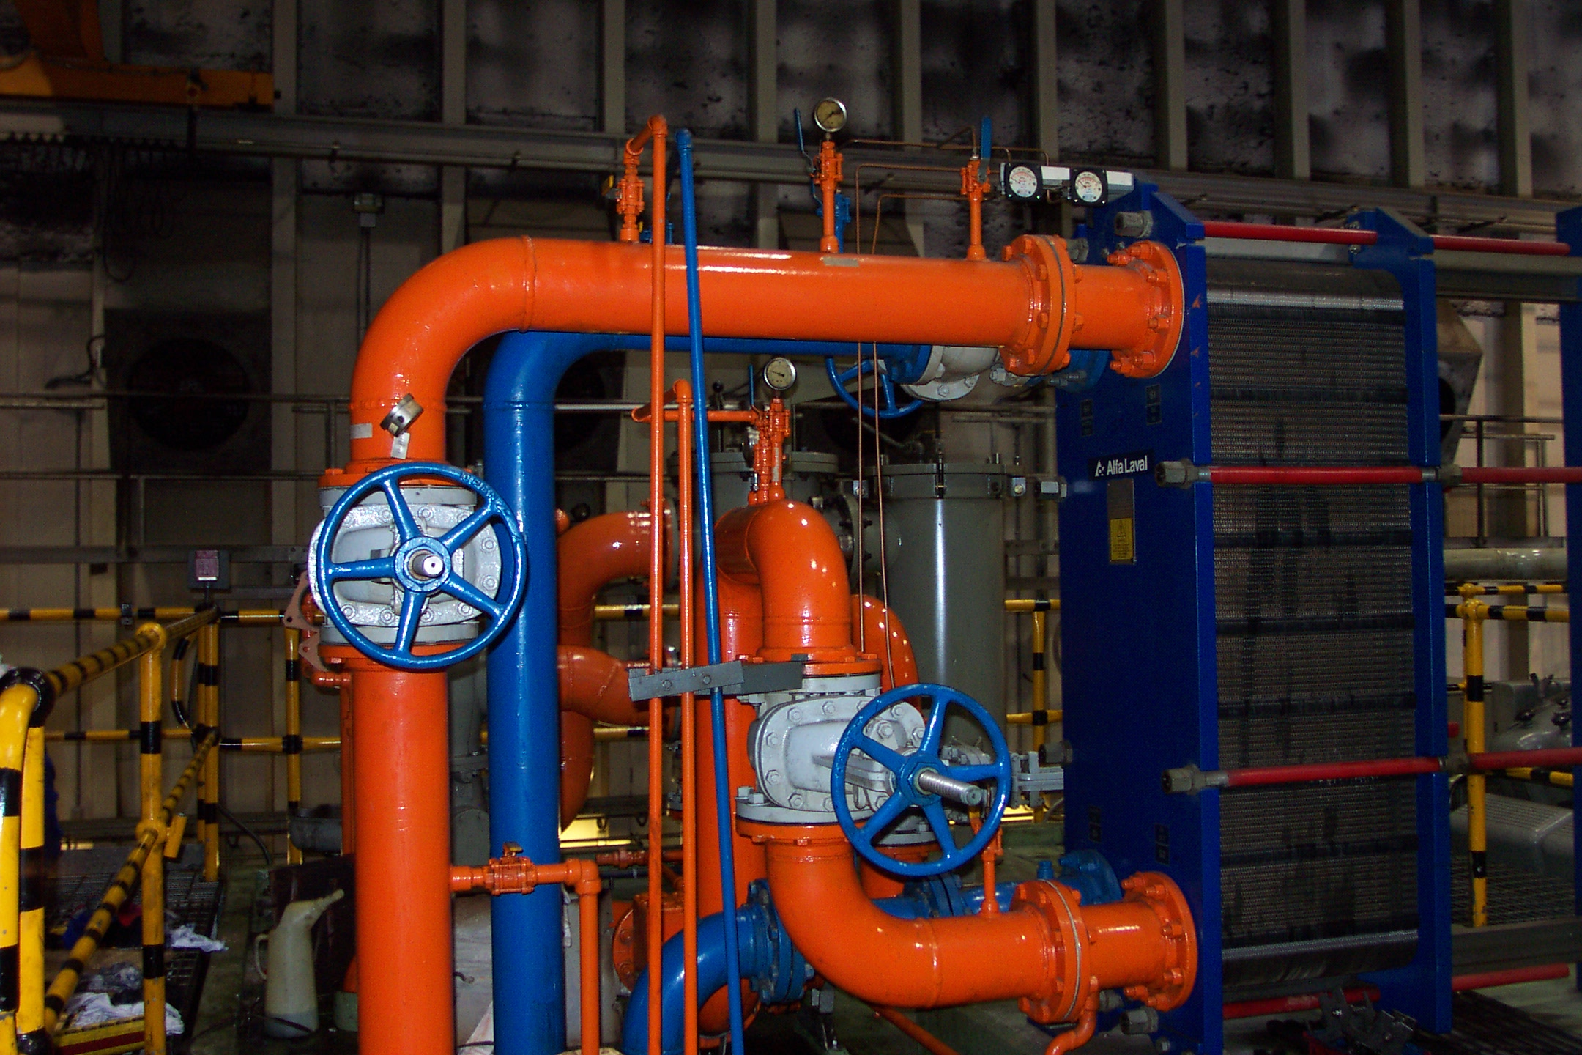

Auditor gives
MEC a B

By GIFF JOHNSON
A detailed performance audit of the Marshalls Energy Company by independent auditors has given the local power company an overall grade of “B.”
The review asked between six and 25 questions in eight different areas — operations, human resources, financial, governance, administration, planning, technical and construction, and public relations and marketing — and only water operations ranked lower than a B-, coming in at C+.
“MEC has performed in a satisfactory manner in each of the various areas considering the size of the utility, the island environment and the developmental nature of MEC in the RMI,” said authors Robert E. Nelson and Michael A. Conduff. They were hired through a grant provided by the US Department of Interior at the request of the RMI Chief Secretary’s office to assess MEC’s performance since it started in the mid-1980s and also to evaluate bids to buy into or manage MEC by local and off-island companies.
“The major strengths of MEC have been the areas that are most important to the customer and the economy,” the report said. “Those areas are reliability and reasonably low cost electricity.” Economic development has been “greatly enhanced in Majuro” because MEC electric rates “were lower than in neighboring islands.” The report explained that over the years, MEC used the profits from the sale of fuel to cover losses in electricity production and maintain low power rates.
The report identified two main areas of concern: The lack of financial reserves and the relatively high system energy losses.
“Most of the other areas needing some attention were administrative functions that should be addressed as MEC goes forward and grows into a more formalized operation in the future rather than the more informal basis as is often the practice in the development of a new utility,” the report said.
“MEC has a history and record of being one of the most reliable electric utilities in the Pacific region,” the report said.
“The main factor leading up to the present financial difficulties facing MEC was Mobil Oil’s decision in early 2004 to discontinue the sale of fuel to MEC on a consignment basis, a practice that had serve RMI, MEC and apparently Mobil Oil well since that practice had been in effect for 13 years.” This, combined with skyrocketing fuel costs, put intense financial pressure on MEC. “MEC’s management, board and the RMI government were also late in recognizing that world fuel prices would not return to their 2003 levels. As a result they did not adopt a rate tariff that recognized the increased fuel cost until FY2005 resulting in two years of serious financial losses.”
Financial problems identified in the report include:
• MEC is owed $4.5 million, including $1.1 million from the RMI government, Majuro Water and Sewer Company and other government parties. MEC began a concerted effort in 2006 to collect accounts receivable.
• MEC has not developed or maintained any cash reserves, which the report describes as ‘a major failing of MEC.” A reserve fund of about $2.5 million to $3.5 million per year as a reserve fund would be appropriate. Besides holding money for emergencies, the utility should also maintain funds for replacement and renewal of plant and equipment.
• To be considered a viable ongoing enterprise, a utility must assure that its revenues are at least covering actual operating costs. “MEC has not been meeting this standard for many years. Although it has used other revenues to occasionally show positive income, in reality MEC has been in a negative income status for many years. The electric rates have simply not been sufficient, even with supplements from the sale of fuel to the fishing fleets and supplements from the US Compact, to pay for operating expenses associated with providing electrical service.”
Among the main recommendations of the report are that the government should not allow short-term problems to overshadow the long-term values of MEC assets. It urges against any change that will “dilute RMI’s ownership share to the point that RMI no longer has the principal say in the direction of the utility.”
Among a variety of recommendations:
• Bring MWSC more fully into alignment with MEC to reduce costs and streamline operations.
• As MEC has significant interest in maintaining the profitable fuel sales operation, it should remain a part of MEC’s operation. But as it is different from providing electricity or water, it should have its own full-time expertise and oversight. And fuel operations should be extended to Ebeye, Wotje and Jaluit to take advantage of bulk purchasing.
• Pay off debt to Mobil and banks that has resulted from the need to buy fuel so that a cash account can be created to allow for future purchases.
• Once the fuel sales operation is back on a cash basis, use a portion of the profits to create a fund for emergencies or contingencies.
• Conduct an immediate study of operational and maintenance losses, including reviewing the policy of providing free or reduced electric service to certain individuals and customers, the policy of landowner power subsidies, non-metered street lights on private property and the use of prepaid meters for lifeline or other customers who have difficulty in budgeting for electric bills.

SK, PII bids won’t benefit RMI in the long term

Although the independent review of bids by SK Networks and Pacific International Inc. has been a tightly guarded document, the detailed performance audit of MEC operations includes some discussion of these proposals.
The report by Robert E. Nelson and Michael A. Conduff cautions against a change in MEC’s present status, which they said is run for the benefit of the general public.
The report notes that in general the proposals from the two companies “request full possession of the fuel tanks and request some limitations on RMI’s present eight cent per gallon import tax and three percent gross receipts tax,” and also propose to bring in new top management and supervisors for the various electric department functions.
But the assessment said these proposals are more in the companies’ interests than the RMI’s.
“The proposals in general offer a short-term solution to a critical financial situation,” the report said. “There is a real possibility that the long-term benefits of the public-private cooperation arrangement will accrue more value to the private party rather than to RMI, MEC and the customers of MEC as compared to a continuation of MEC’s present operation.”

MEC electric losses and fuel profits

Description 2000 2001 2002 2003 2004 2005
Electric losses 1,590,999 3,486,665 1,610,675 2,937,351 3,865,467 5,913,931
Fuel sale profit 1,190,734 1,398,466 2,130,389 1,957,727 1,850,141 2,198,091
Net profit (loss) (400,265)* (2,088,199)* 519,714* (979,624)* (2,015,326)* (3,715,840)*
* Note: Compact funding in 2002 and 2003 produced a net profit for MEC in those years; other revenues in 2000 gave MEC a net profit for 2000, and slightly reduced its overall losses in 2001, 2004 and 2005.

