From the Marshall Islands Journal Friday, November 10, 2006

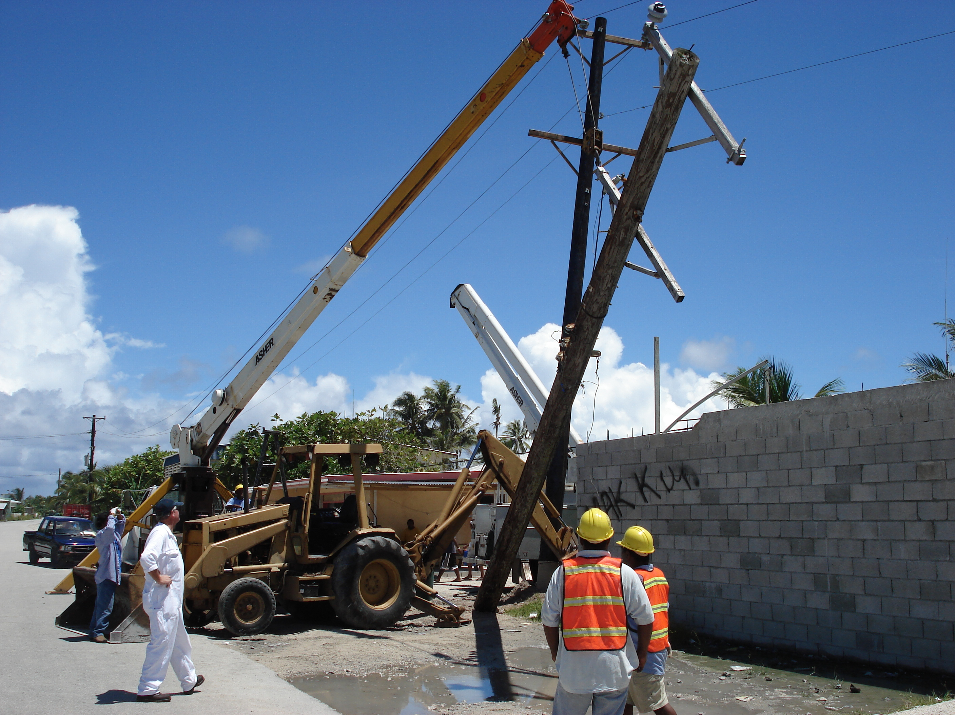

MEC fixes its
core issues

By GIFF JOHNSON
When you think about MEC problems, you probably think “fuel costs.”
When power plant engineer Ian Pickering and distribution chief Sam Langrine think about problems, they think about the fact that as many as 50 percent of the poles in Majuro are termite eaten and in need of replacing — just six years after most of them were replaced with new poles with an anticipated life expectancy of 30-to-50 years.
“We changed out all the rotten untreated poles from the Trust Territory period in about 2000,” Pickering told the Journal. “Once we put up the new ones, I figured that’s it. We won’t be doing that again.”
Power poles are expected to last from 30-to-50 years, he said.
But that expectation has run headlong into Majuro’s feisty termites, and guess which one won?
“Termite infestation has gotten really bad the last several years,” Pickering said.
MEC has temporarily run out of replacement poles, and has ordered in a new shipment.
A development that amazes Pickering is that the termites are attacking the poles from the top down. “I didn’t know that termites would fly to the top of a pole,” he said.
MEC first became aware of the problem several months ago when a pole near the former RRE Long Island grocery store snapped and fell across the road. After discovering that this pole, replaced just five years ago, was hollow inside from termites, MEC started going around the island testing poles. Nowadays, people often can see MEC crews wandering around tapping poles with hammers to check for termite damage.
“I estimate maybe 50 percent of the poles are termite infested,” he said. “We’ve been changing out the most seriously damaged poles.”
During the series of planned outages last month, several such termite damaged poles were replaced. As a prevention measure, MEC is now installing all new poles with a so-called termite prevention “sock” — which is used by many utility companies in Hawaii and the US. “I hope the socks work, though we won’t know for a while,” Pickering said. In addition, MEC is now sealing the tops of the newly installed poles with bitumen as another termite prevention method.

