From the Marshall Islands Journal Friday, January 19, 2007

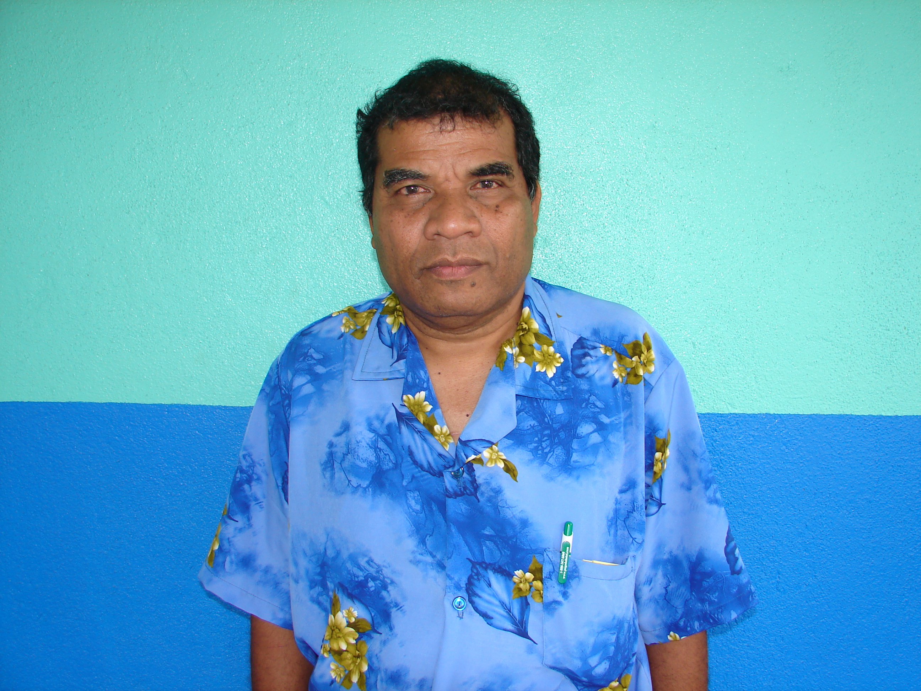

MEC should be praised
for solving the energy crisis

The nation’s fuel problems were downplayed on Friday by Majuro Senator and Marshalls Energy Company board of directors member Alik Alik, who noted that Majuro has not been in the dark.
“There is no problem with fuel now,” said Alik. “Fuel has gone to Ebeye.”
Praising the work of MEC to continue to provide power to the nation’s capital without a hiccup, Alik said that people should be thanking the energy company.
“Why isn’t anyone thanking MEC for the work we’ve done?” he asked.
Meanwhile, with Ebeye’s fuel and energy situation still up in air with the impending departure of ExxonMobil, Kwajalein Senator Iroij Mike Kabua requested Speaker Litokwa Tomeing and the government to give Ebeye landowners permission to talk with Mobil.
“Allow us to sit with the President of Mobil,” asked Kabua. “Let us talk to them.”
Kabua said he believes that including everyone — both the national and local governments and the landowners — in the talks with ExxonMobil will be more productive.
“Let’s sit together and work this out and find a win-win solution for the Ebeye community, the national and local governments and for Mobil,” Kabua pleaded. “It’s not fair for us to make stabs at each other during these (Nitijela) sessions. We all need each other. (We) landowners can’t go on our own just as the government can’t make decisions on its own.”
In comments made during the same session by Minister of Finance Brenson Wase reagarding ExxonMobil’s pull-out from Ebeye, Wase made the point that while “the national government has responsibilities (to maintain energy standards) for Ebeye,” he alluded that Mobil is not ready to reinvest in Ebeye due to the fuel company’s uncertainty over its land lease on Ebeye.
“They don’t feel secure,” said Wase. “Mobil is not ready to reinvest in Ebeye because of uncertainty over the land lease.”

