From the Marshall Islands Journal Friday, January 5, 2007

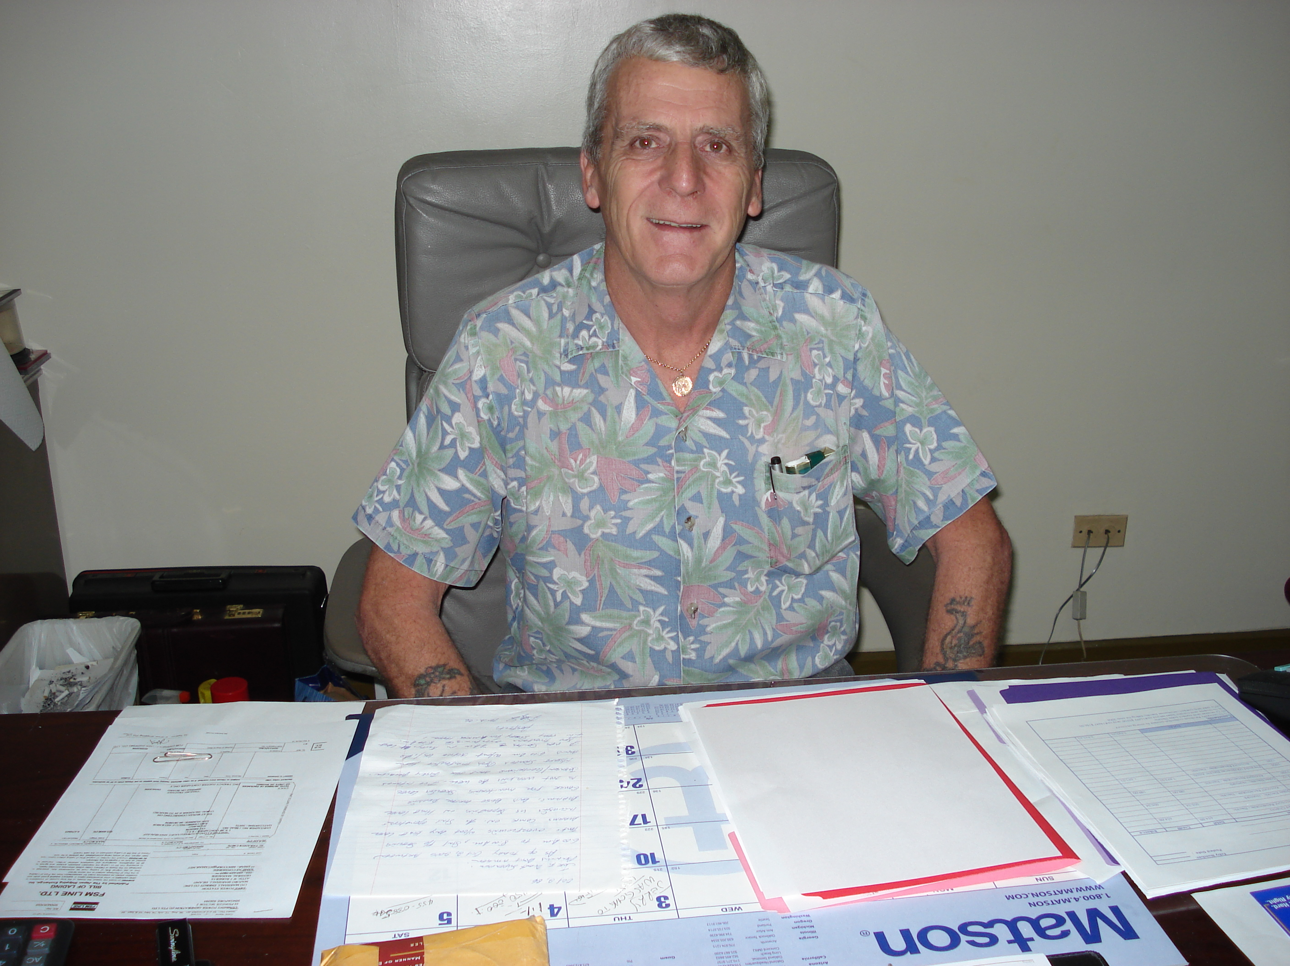

SK to negotiate
with MEC next week

Major negotiations on an SK Networks bid to buy into MEC are expected to start in Majuro mid-next week, with the arrival of a high-power task force team from South Korea.
The SK Networks group is expected to begin arriving January 16 to further discussions with the RMI government related to the privatization of the Marshalls Energy Company.
From the MEC side, general manager Billy Roberts, who has been off-island since September, arrived this week in Majuro for the discussions with SK and other companies who are showing interest in MEC.
SK has advanced a proposal to invest $12 million in MEC in exchange for a 51 percent controlling interest in the company.
From SK, manager Jae Ko, finance manager Seung Ho Cho, planning manager Chung Sik Hyun, planning assistant manager Kwang Ho Lee, legal manager Bong Gul Jang, public accountant Jong Hoon Won and two other certified public accountants are expected to arrive on September 16.
The following day, SK Networks general manager William Choe is expected to arrive on the evening flight from Guam.
The purpose of the visit is to follow through on final “due diligence” on the MEC investment project.

