From the Marshall Islands Journal Friday, January 30, 2009

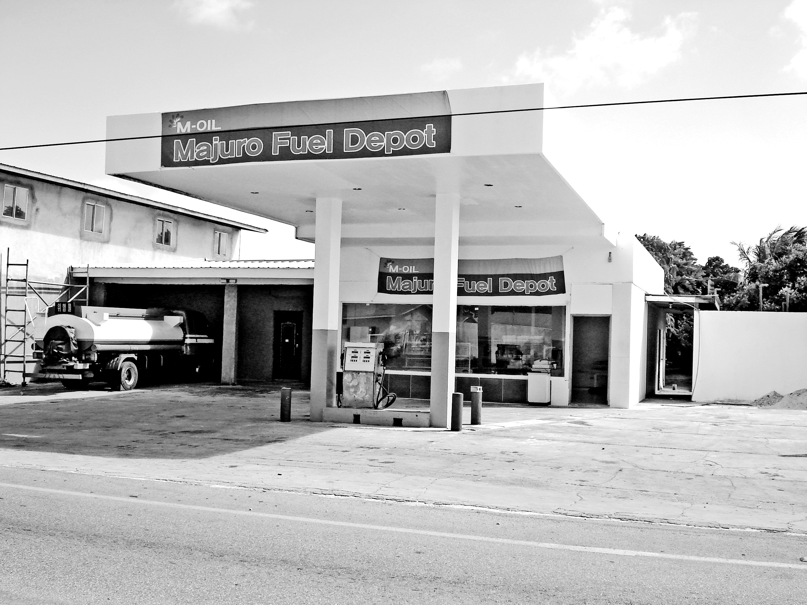

Bing offers huge fuel drop

By DOUGLAS HENRY
Majuro Fuel Depot is now selling MEC-supplied diesel to Marshallese residents at the low price of $3.43 a gallon, by far the lowest rate in Majuro. Mobil-supplied diesel is being sold for over $5 per gallon at downtown stations.
The new station is located next to Special Restaurant in Batkan, Long Island area.
The gas station/convenience store opened Monday this week. Local entrepreneur Chris Bing is the owner.
Bing says his plan is to “help out on the gas price outrage, by selling gas at a reasonable price. A Marshallese company helps the Marshallese community.”
Bing said he has received the okay from Mobil to supply gasoline, “but I’m still waiting for a reasonable or better rate from other suppliers, so for now gas still remains a question.”
“About 90 percent of Majuro gas stations focus on gasoline, but right now, I want to focus on distributing diesel,” said Bing.
Bing said pipes recommended by RMI Environmental Protection Authority are in use at the new station.
Although Mobil doesn’t deliver fuel past the bridge, he said that’s not a problem. “We have our own delivery tanker.”

