

MARSHALLS ENERGY COMPANY Inc.
P.O. Box 1439
Majuro, Marshall Islands MH96960
Telephone: (692) 625-2020 Fax: (692) 625-2021
Website: www.mecrmi.net

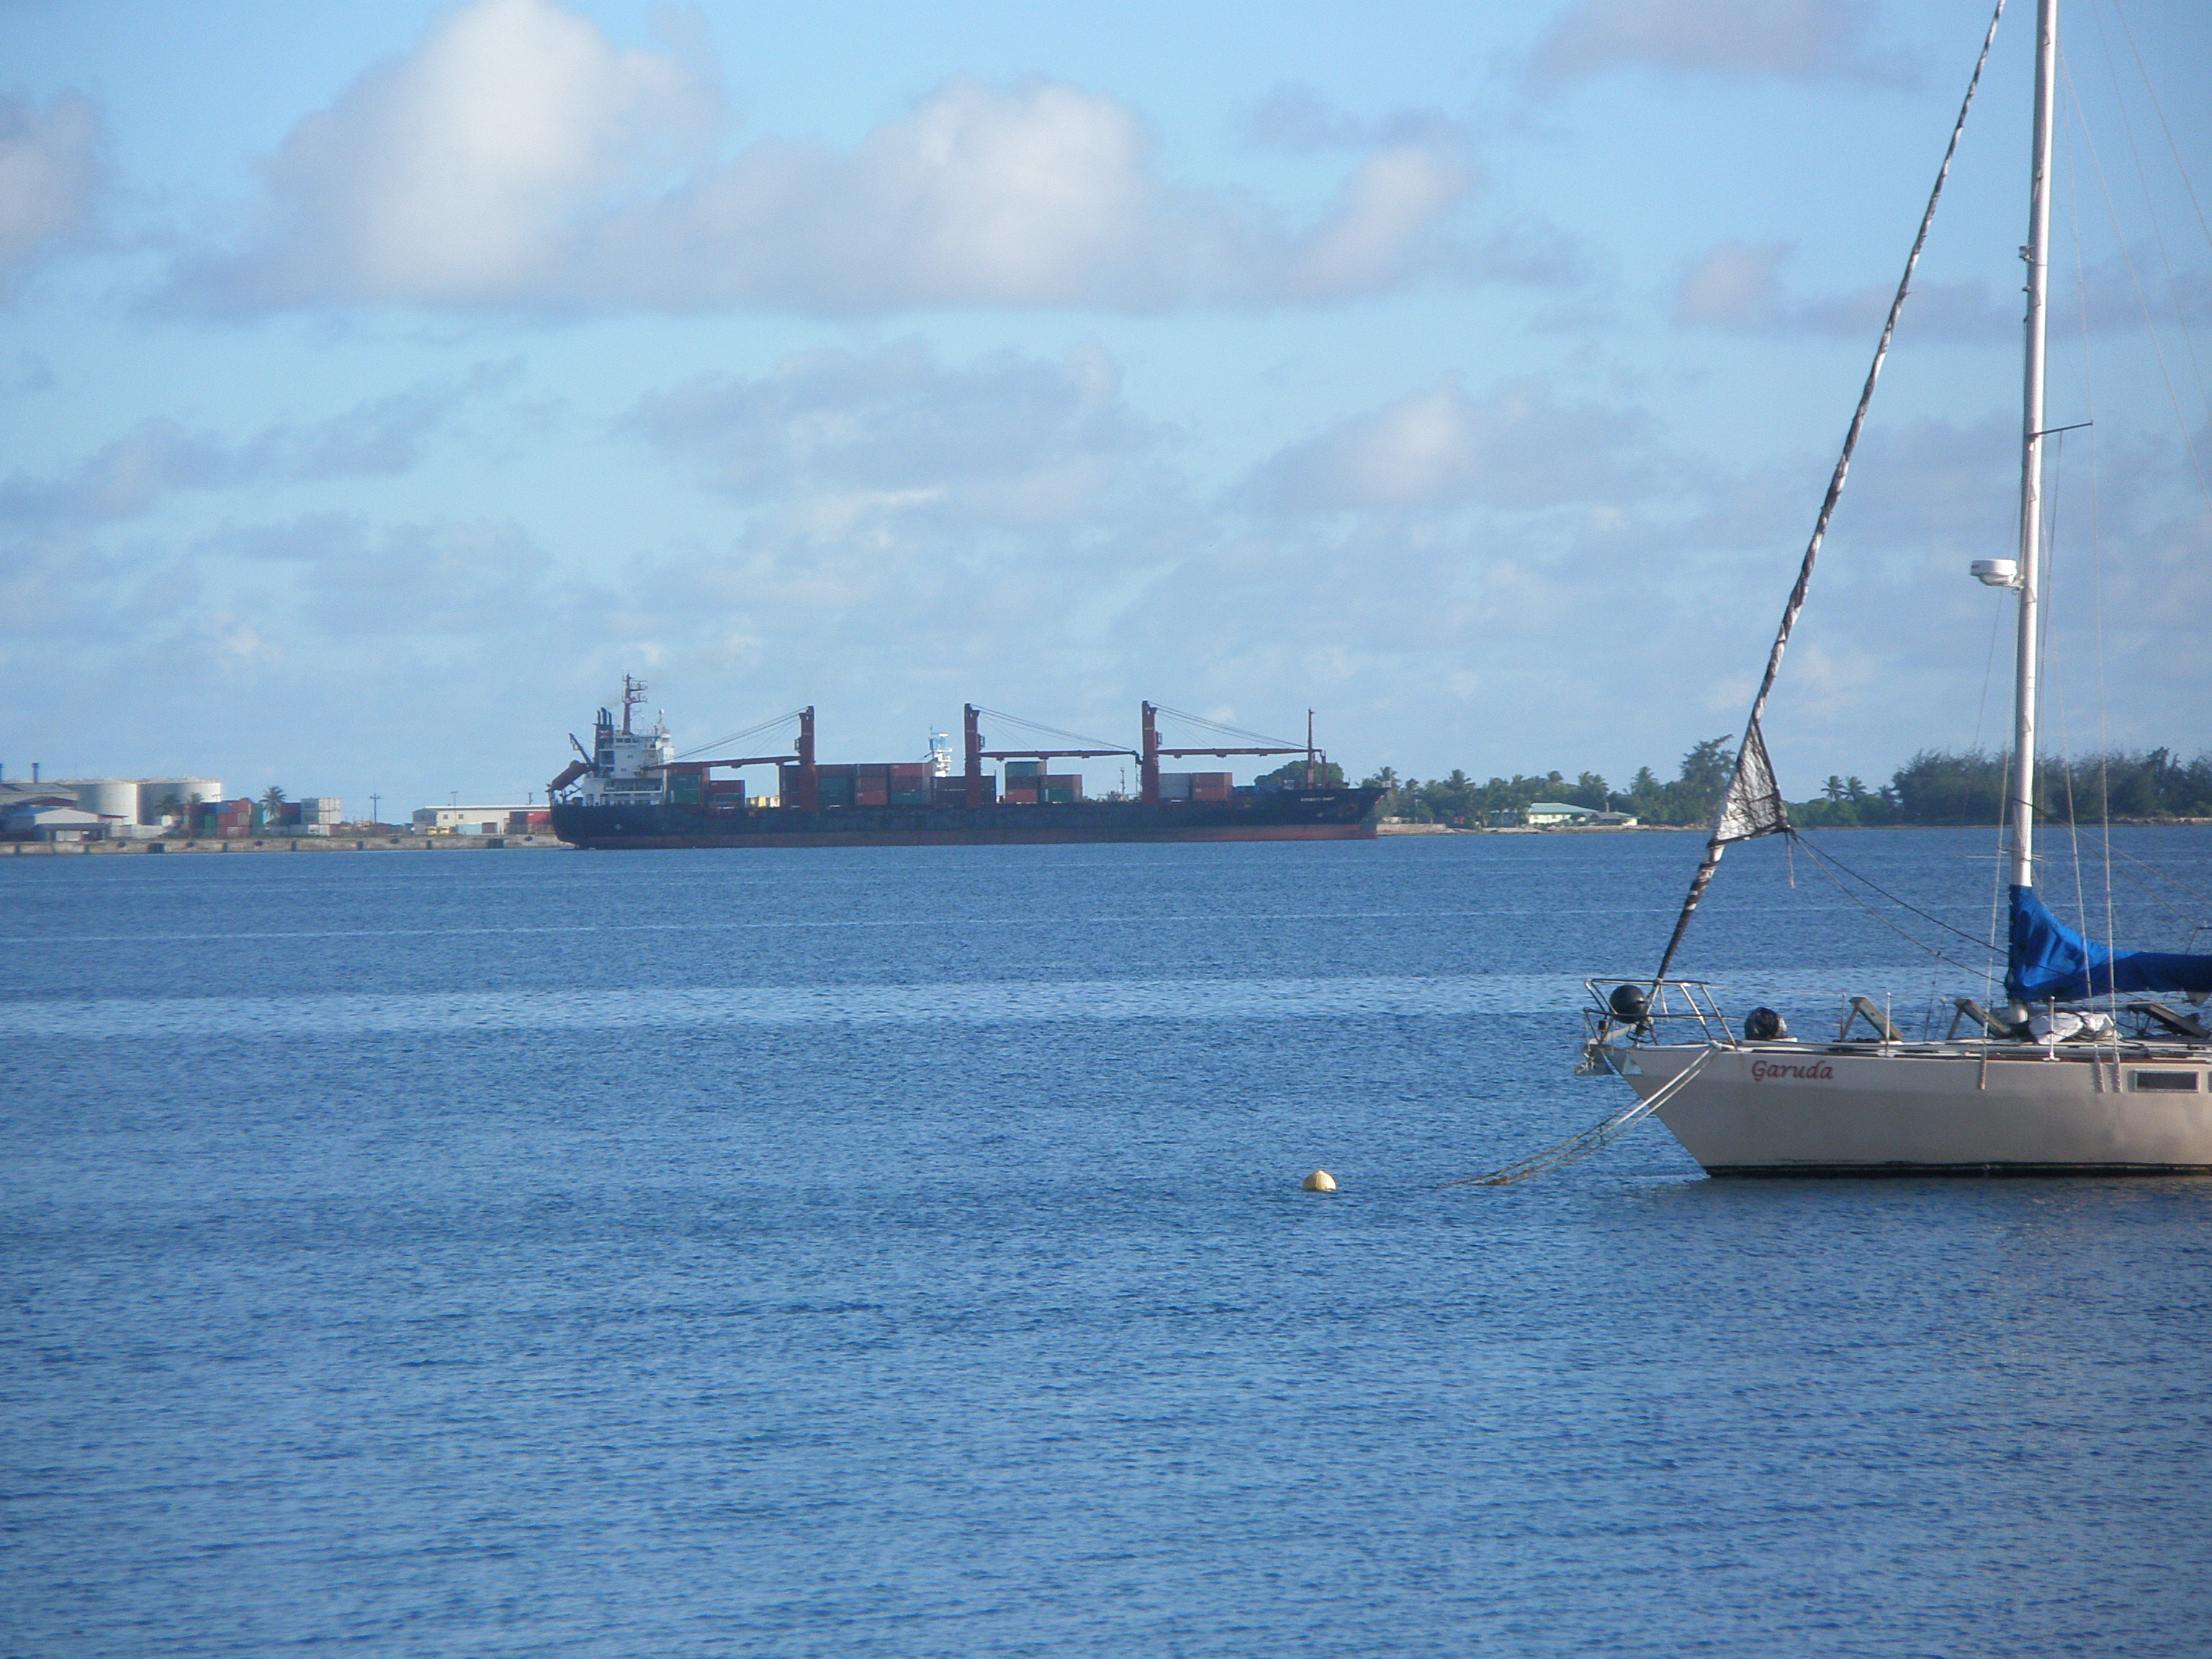

PORT OF MAJURO

Republic of the Marshall Islands

Terminal Handbook

PORT OF MAJURO TERMINAL HANDBOOK

Table of Contents

1. PORT AND TERMINAL HANDBOOK Error! Bookmark not defined.
2. FIRE AND EMERGENCY 3
3. SAFETY 4
4. WARNINGS 5
4.1 Smoking 5
4.2 Alcohol/Drugs 5
4.3 Environnemental Protection 5
4.4 Electrical Equipment Including Cameras 5
4.5 Weather Warning 6
5. COMMUNICATIONS 7
5.1 Early Communications. 7
5.2 Ship Shore Communication - General 7
5.3 Declaration of Inspection, Ship Shore Checklist and Operational Agreement 7
5.4 Ship Shore Communications During Cargo Operations 8
6. RESPONSIBILITY OF OPERATIONS 9
6.1 Responsibility For Loading 9
6.2 Responsibility For Unloading 9
6.3 Code of Responsibility 9
7. DOCK OPERATIONS 10
7.1 Fire Alarm Tests. 10
7.2 General 10
7.3 Gangways 10
7.4 Garbage and Slops 10
7.5 Stores and Spares 10
7.6 Cargo Handling And Bunkering Facilities 10
7.7 Fresh Water 10
8. MOORINGS AND ENVIRONMENTAL CRITERIA FOR BERTHS 11
8.1 General Mooring Guidelines 11
8.2 Mooring Line Size and Material 11
8.3 Snap Back Zones 11
9. SPECIAL REGULATIONS 12
9.1 Ullaging and Sampling 12
9.2 Inert Gas 12
9.3 Immobilisation 12
9.4 Permit to Work on Board a Vessel at the Berth 12
9.5 Hot Work 12
9.6 Testing Radio And Radar Equipment 12
9.7 Tank Cleaning, Purging and Gas Freeing 13
9.8 Loading/Unloading Stores and Spares 13
9.9 Personnel and Vehicular Access 13
9.10 Hose Connection 13
10. PORT AND BERTH RESTRICTIONS 14
10.1 Port Restrictions 14
10.2 Berth Restrictions 14
11. DESCRIPTION AND OPERATIONAL PARAMETER of Delap Dock 15
11.1 General Description 15
11.2 Freeboard Limits 16
11.3 Berth/Product Availability 17
11.4 Approximate Receiving Rates 17
12. Tugs/Mooring Boats/Pilotage 18
12.1 General Towage Information 18
12.2 Pilotage 18
13. DEFINITIONS/ABBREVIATIONS 19

Appendix 1 20
Appendix 2 21
Appendix 3 24

FIRE AND EMERGENCY

IN CASE OF EMERGENCY DO NOT HESITATE TO RAISE THE ALARM

In the event of the following occurring:
- FIRE

- EXPLOSION

- ESCAPE OR TOXIC and/or FLAMMABLE GASES

- ESCAPE OF TOXIC and/or FLAMMABLE LIQUIDS

- RAISE THE ALARM
Sound one or more blasts of the ships whistle each blast of not less than 10 seconds duration, supplemented by a continuous sound of the general alarm system.

- CONTACT THE BERTH

Telephone numbers: Marshall Islands Port Authority: (692) 625-8269 or Agent: (692) 625-2021
UHF/VHF communication channel: on Dock Band or by Ship’s VHF radio Channel 16 to call the Marshall Islands Port Authority and/or Ships Agent

ACTION-SHIP | ACTION-BERTH
Emergency on your ship | Emergency on a ship
- Raise the alarm | - Raise the alarm
- Cease all cargo/ballast operations and close all valves | - Contact ship
- Inform berth | - Cease ail cargo/ballast operations and close all valves
- In case of fire, fight fire and prevent from spreading | - Stand by to disconnect hoses or loading arms
- Stand by to disconnect hoses or loading arms | - If necessary, stand by to assist fire fighting
- Bring engines to standby | - Inform all ships in the vicinity
 | - Implement berth emergency plan
Emergency on another ship | Emergency ashore
Stand by, and when instructed: | - Raise alarm
- Cease all cargo/ballast operations and close all valves | - Cease all cargo/ballast operations and close all valves
- Disconnect hoses or loading arms | - In case of fire, fight fire and prevent it from spreading
- Bring engines and crew to standby, ready to unberth | - If required, stand by to disconnect hoses or loading arms
 | - Implement berth emergency plan
IN THE CASE OF EMERGENCY, DOCK PERSONNEL WILL DIRECT
THE MOVEMENT OF VEHICULAR TRAFFIC ASHORE

SAFETY

Responsibility for the safe conduct of operations while a ship is at this terminal rests jointly with the master of the vessel, and the responsible terminal representative.(MEC Operations Officer) Therefore, before operations start, it is incumbent upon both ship and shore that there is full co-operation and understanding on the safety requirements set out in the Ship/Shore Safety Check List which are based on safe practices widely accepted by the oil and tanker industries.

The master is expected to adhere strictly to these requirements throughout the stay alongside this terminal and MEC personnel will do likewise and co-operate fully with the ship in the mutual interest of safe and efficient operations.

Before the start of operations, and from time to time thereafter, for our mutual safety, the MEC Operations Officer together with a responsible Ships Officer, will make a routine inspection of the ship to ensure that the questions on the Ship/Shore Safety Check List can be answered in the affirmative. Where corrective action is needed, the terminal may not agree to operations commencing or should they have been started, may require them to be stopped.

Similarly, if the master considers safety is endangered by any action on the part of MEC engaged staff or by any equipment under MEC’s control, the master should demand immediate cessation of operations until the situation is rectified.

THERE CAN BE NO COMPROMISE WITH SAFETY.

WARNINGS

Smoking

Smoking is strictly prohibited in the Dock area and on board vessels alongside except in those spaces on board specifically designated by the Master and dock controller/shore officer as "Smoking Areas'. Failure to comply with this regulation will involve cessation of operations and may result in the vessel vacating the dock pending a complete investigation and receipt of written assurance from the Master that effective controls have been established.

MEC reserves the right, to prohibit smoking, at any time, in any place on board a vessel and adjacent to the dock area. Smoking is also prohibited in any place within the dock areas, except designated buildings as directed.

Alcohol/Drugs

Masters are advised that operations will cease, when a person or persons involved in operations whose actions are not under proper control as a result of the use of alcohol/drugs and or fatigue.

Operations will not resume until the matter has been reported to and fully investigated by relevant authorities and that MEC considers it safe to do so and delay or cancellation in a vessel's departure could result.

Access to the dock restricted area for a person(s) similarly suspected of being affected by alcohol/drugs will be denied.

Environmental Protection

The Environmental Protection Authority is the statutory body having primary responsibility for environmental protection in all port waters including when vessels are alongside a berth.

The Master of a vessel berthed at the fueling dock point must comply with the requirements of the above acts and policies and:
- Not cause or permit refuse of any kind to be discharged from the vessel or its scuppers into port waters.
- Not cause or permit a person to pump or discharge any oil, spirit or flammable liquid into port waters.
- allow the vessel to emit excessive funnel smoke

The Master of a vessel berthed at the any piers engaged in international trading must not discharge ballast into the waters of the port without having approval from the RMIEPA.

Electrical Equipment

Portable Computers, Mobile Phones, Pagers and Cameras may only be used in or on:
- Permanent buildings as nominated by the Dock Security Officer.
- Areas on the ship nominated by the Master.

Note: In special circumstances certain types of cameras may be used with the approval of the Master and dock controller/ shore officer, however, before this approval is given a permit for the use of the camera must be obtained from the Marshalls Energy Company General Manager or representative.

Use or possession of these devices in other than the areas stated above will be considered as a serious breach of safety rules.

No attempt shall be made to change a battery for mobile phone, pager, UHF/VHF radio unless it is inside a permanent building.

Weather Warning

Adverse weather conditions that my be present during berthing, operations or departure will be monitored by the vessels Master and MEC Personnel on the Delap Dock. Heavy Rain, winds or waves my require a delay in operations for safety reasons.

Regular weather updates can be gained from contacting the Marshall Island Weather Station (NOAA) at (692) 247-3214

Masters are reminded of the need to continue to monitor transmissions of weather forecasts and to always remain securely moored while alongside the berth.

COMMUNICATIONS

Early Communications

Where possible, ships proceeding to the Port of Majuro to Discharge cargo should forward telephone/fax contact details to the vessel Agent at least four days before the ETA at the berth. Arranging early contact increases efficiency and allows the ship and dock controller adequate time to jointly plan for the intending load or discharge, thus taking into consideration operational difficulties or constraints upon either party.

Information Required From Discharge Vessels Prior To Arrival
- ETA, arrival draft, gross revenue tons and Port of registry.
- Stowage of all cargo on board and preferred order of discharge.
- Maximum freeboard measured from manifold to water surface during discharge.
- Confirm maximum draft alongside will not exceed 11 meters (33').
- Best estimate of discharge time and discharge rate.
- C.O.W plan
- Manifolds numbered from forward to be used for discharge.
- Confirm 6” (150mm) reducers will be fitted to discharge manifolds.
- Confirm vessel oil tight and scuppers sealed on arrival.
- Quantity, origin and stowage of slops and if present cargo commingled with slops.
- Free water in slops and cargo.
- B/L MT, ship's loaded MT and Densities
- Confirm that all cargo and ballast operations are in accordance with the ship’s loading/discharge manual

Ship to Shore Communication – General

On arrival to the berth the ship shall monitor channel 16 or designate an alternate channel for communications. This will be the primary voice communication link between the vessel and the dock controller or shore officer. A secondary means of voice communication for ship/shore operations will be via mobile telephone primarily designated for this use (692-455-6724).

Identification of the name of ship should always be included in ship to shore voice communications to avoid misunderstandings.

When using the hand held radios onboard ships it is good practice to stand reasonably close to the ship’s windows to reduce the chance of interference to ship shore communications.

Declaration of Inspection, Ship Shore Checklist and Operational Agreement

On arrival at the berth, the dock controller/shore officer will present each vessel with a copy of the above documents. The various forms, information and procedures laid out in the documents formalise the conduct and procedures governing and regulating ship/shore operations at the dock which are to be mutually agreed before operations commence. This document is made up from:
- Safety Letter to Master
- Emergency Procedure Notice
- Declaration of Inspection (DOI)
- Ship Shore Checklist, (General, Gas and Chemical whichever is applicable)
- Shore Hose, Pipeline and Hard Arm declaration
- Loading and Discharge Plans.

The agreements reached in the document remain in force throughout the time a ship remains alongside the dock. Any changes made to these agreements during the course of the cargo operation must be again agreed in writing.

All items contained in the DOI and ship shore checklist must remain constantly under review however, the ship and shore, must jointly recheck those items requiring formal recheck at agreed intervals. Rechecking should be indicated in the appropriate box by additional ticks. The personnel carrying out the checks should then sign and note the date and time in the appropriate boxes. The maximum period between joint ship and shore rechecking should be no more than 12 hours.

Ship Shore Communications During Cargo Operations
Good communications between ship and shore is an integral part of a successful operation. However, during cargo operations, if for any reason it becomes necessary to stop cargo in an emergency, the dock controller/shore officer should be immediately notified by UHF radio of (name of ship) EMERGENCY STOP
Likewise, ship’s personnel on deck can raise the alarm to shore personnel who can activate the dock emergency stops.
At all other times it is good practice to offer as much notice as possible before topping off tanks or requiring a stop. The shore preference is for a countdown commencing 30 minutes, 15 minutes, 10 minutes, 5 minutes and so on until STOP. The actual countdown and arrangements should be agreed with the MEC Dock Supervisor during pre - discharge/load discussions.

RESPONSIBILITY OF OPERATIONS

Responsibility For Loading

Ship's personnel are advised that responsibility for the loading operation on board the ship rests solely and absolutely with the Master. It is the responsibility of the ship's personnel to operate valves and to ensure safe and secure connection of all transfer apparatus to the ship’s manifold. Ship's personnel are advised that responsibility for the discharge or escape of oil from a vessel rests with the ship. In the event of a prosecution being taken by the appropriate authorities heavy penalties together with liability for dispersal costs and damages for pollution damage is provided for by legislation.

Responsibility For Unloading

Ship's personnel are advised that responsibility for the unloading operation on board the ship rests solely and absolutely with the Master. It is the responsibility of the ship's personnel to control pumping rates, to operate valves and to ensure safe and secure connection of all transfer apparatus to the ship’s manifold. Ship's personnel are advised that responsibility for the discharge or escape of oil from a vessel rests with the ship. In the event of a prosecution being taken by the appropriate authority’s heavy penalties together with liability for dispersal costs and damages for pollution damage is provided for by legislation.

Code of Responsibility

Emphasis is placed on the fact that the completion of a safe and successful cargo handling operation is dependent upon effective CO-OPERATION and CO-ORDINATION and (“3 Cs”) between all the parties involved. All operations should be conducted in the spirit of mutual agreement.

DOCK OPERATIONS

Fire Alarm Tests

This siren is tested during signing of ship/shore safety checklist.

General

All operations at the Delap Dock are carried out in full accordance with the recommendations of the ISGOTT (International Safety Guide for Oil Tankers and Terminals - Fifth Edition) and United States Coast Guard Regulations (33 CFR). These documents should be referred to in respect of all operations.

Gangways

A gangway or brow is not available at the dock. The vessel will be required to put in place and use the vessel’s accommodation ladder for access. The vessel must supply a suitable safety net.

Garbage and Slops

Approved garbage reception facilities are available in the port via Majuro Waste Company. There is no accommodation to handle slops.

Stores and Spares

See section 9.9.

Cargo Handling And Bunkering Facilities

Marshalls Energy Fuel inlet for loading are 24” Manifold with 16’ Line.
Maximum operating pressure on all hoses 100 psi.
All presentation flanges 6” (150mm) ASA 150 flanges

Fresh Water

Fresh water is available at the Delap Dock. Delivery is made either via shoreline connection or be 2500 gallon water tanker. Due to limited water availability at time, it is advisable to fill tanks prior to arrival at the Port of Majuro.

MOORINGS AND ENVIRONMENTAL CRITERIA FOR BERTHS

General Mooring Guidelines

The mooring facilities are designed to permit a tanker to remain safely moored during all expected environmental conditions other than typhoons.

When wind speeds exceed an average speed of 40 knots, berthing and unberthing movements are likely to be delayed. Hoses and hard arms will be disconnected until such time as conditions improve. The Marshall Islands Ports Authority will make all determinations concerning safety of operations.

Mooring Line Size and Material

Mooring lines of the same size and material must always be used for all leads in the same service, i.e. all spring lines must be of the same size and material and all breast lines must be of the same size and material. Mixed moorings in the same service are not permitted.

Snap Back Zones

Ship’s mooring lines can pose a great danger to personnel ashore and aboard. Handling of mooring lines has a higher potential accident risk than most other shipboard activities. The most serious danger is snap back, the sudden release of the static energy stored in both synthetic lines and flexible steel wires.

Line handlers must stand well clear of the potential path of snap back, which extends to the sides and far beyond the ends of the tensioned line. Figure 8.3 illustrates potential snap back danger zones.
fig 8.3

SPECIAL REGULATIONS

Ullaging and Sampling

Wherever possible, ullaging and sampling of ships tanks should be achieved by the use of closed sampling equipment. Under no circumstances are shore personnel to open any tank or vapour lock without approval from the ship’s officer on duty and a representative of the ship’s staff being present.

When it is not possible to undertake closed gauging and/or sampling operations, open gauging systems will need to be employed and the precautions detailed in ISGOTT 7.2 (7.2.1, 7.2.2, 7.2.3, 7.2.4 including Fig 7-1 on page 63) adhered to.

Inert Gas

If a vessel is fitted with an inert gas system then this system must be fully operational (in accordance with Class requirements) and used at all times. In the event that a vessel’s inert gas system is not functioning or not functioning as required, cargo operations must cease immediately and may not resume until the system is repaired or written permission is given from AMSA, port authority and dock controller/shore officer.

Immobilisation

May be permitted upon application to the Marshall Islands Ports Authority and with the permission of the Dock Security Officer. A detailed description of the work being undertaken and an estimation of the actual time of immobilisation will be required.

Permit to Work on Board a Vessel at the Berth

When any repair or maintenance is to be done on board a vessel moored at the Dock, the responsible ship’s officer must inform the Marshall Islands Ports Authority in writing. Agreement should be reached on the safety precautions to be taken, with due regard to the nature of the work.

Hot Work

Before undertaking hot work, permission must be granted by the Palau Port Control and the Shell Guam Operations Manager. All hot work permits to be counter signed by shore officer and ship’s officer.

Hot work is usually restricted to engine room and boiler spaces.

Testing Radio And Radar Equipment

Permission to test radio and radar equipment is only permitted by a permit signed jointly by the shore officer, the Master and the technician responsible.

Tank Cleaning, Purging and Gas Freeing

The Master of any vessels requiring to clean, purge or gas free tanks which have previously contained liquid hydrocarbons, including crude oils with high sulphur must obtain permission from the Palau Port Control.

Loading/Unloading Stores and Spares

In certain circumstances, shore officer and Master’s approval, stores and spares may be loaded from the dock using shore lifting gear.

Selected vehicles may be allowed access past the barriers to the Dock head for the purposes of dropping lubes, stores or spares. However, entry may only be granted subject to approval of the dock controller/shore officer and Master after satisfying security and safety arrangements.

Approval to deliver certain stores or spare parts to the dock head past the barriers may be granted before a vessel berths subject to the dock controller/shore officer approval. Approval will depend upon nature of the stores or spare parts to be delivered, whether the berths are free or other circumstances.

NOTE: A LOP may be issued to the ship if loading stores causes any delay to loading/unloading operations.

Ship's agents have the responsibility for removal of pallets and or packaging left on the dock after a vessel departs.

Personnel and Vehicular Access

Dock personnel and gates secure entry and exit from the dock. Any direction given by dock personnel must be followed.

Hose Connection

Hose connections will be made by joint operation between vessel and shore personnel. Vessel will lift the hoses to the vessel using the ship crane. Vessel personnel will then restrain the hose, remove the hose blind and connect and fasten the hose end to the manifold. MEC utilized an 8” hose with 16” Manifold.

PORT AND BERTH RESTRICTIONS

Port Restrictions

There is a maximum draft limit for port entry/exit. The proposed berth determines draft limits.

The movement of all vessels will be regulated by the Majuro Port Control. A pilot is required.

Berth Restrictions

The Commercial Port waterfront facilities used by Shell for transfer operations are capable of handling vessels of the following dimensions at the following locations:
Berth | Purpose | Designation | Limitations
Delap | Fuel Oil Transfer  International Cargo |  | 33 ft (8 m)max draft, LOA max 850’ (???m)  No Dead Weight Restriction

DESCRIPTION AND OPERATIONAL PARAMETERS OF DELAP DOCK

General Description
There are 2 docks in the Port of Majuro: Delap Dock (Marshalls Energy Company and Uilga Dock (Mobil Micronesia) for the purpose of this report, just the Delap Dock is included

The Delap Dock is 1050 Feet long with mooring bulloks approx 50 feet apart

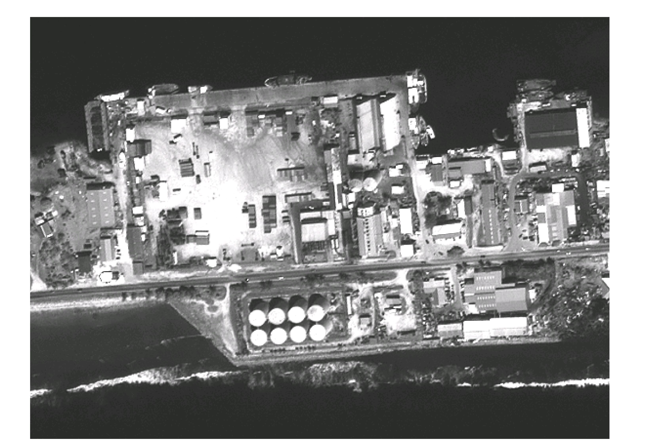

Freeboard Limits
Freeboard is limited by the ship boom, which lifts hoses to the vessel and available hose length.

Maximum freeboard at Delap Dock 11 m (33’) at MLW

Freeboard in this case is measured from 600mm (2’) above the ships rail at the manifold to the surface of the water and this restriction reflects the maximum safe operating height envelope of the loading/discharging arms.

Berth/Product Availability
 | <<- | Berth
Product |  | Delap | Remarks
Gasoil less that 0.5 Sulfur |  |  | 2 and 8” Lines

Approximate Receiving Rates
Receiving rates vary considerably as a result of the delivery vessels pumping rate.
MEC utilized a 16” Line for receipt of fuel.

Product | m3/h | bbls/hr
Gasoil less than 0.5% | 640 | 4,750

Tugs/Mooring Boats/Pilotage
Tug Service is not available in the Port of Majuro

General Towage Information

Towlines are supplied from the ship.

Pilotage
Pilotage is compulsory and is provided by the Marshall Islands Ports Authority (MIPA) 24 hours notice is required prior to pilotage into the Port.

FOR ALL FUEL CARRIERS, THE PORT OF MAJURO IS A DAYLIGHT ONLY ENTRY AND EXIT PORT

DEFINITIONS/ABBREVIATIONS

ISGOTT (International Safety Guide for Oil Tankers and Terminals) Fifth edition is also used and referenced as a basis for all standards and procedures.

Other reference documents are:
- OCIMF - Mooring Equipment Guidelines (Second Edition 1997)
- IMO Crude Oil Washing Systems (1983)

API API Gravity, numerical system used on petroleum products corrected to density and relative density.

ASA American Standards Association

BOL (B/L) Bill of Lading. Document issued by the cargo supplier stating the quantity of material delivered to the vessel.

BCM Bow to Center of Manifold distance

EPA Environmental Protection Authority

ETA Estimated Time of Arrival

HHW High High Water

ISGOTT International Safety Guide for Oil Tankers and Terminals

OCIMF Oil Companies International Marine Forum

LOA Length Overall. Length of a vessel taken over all extremities.

LOP Letter of Protest

MLW Mean Low Water

MIPA Marshall Islands Ports Authority

SBT Segregated Ballast Tanks

SDWT Summer Dead-weight Tonnes

Appendix 1

DOCK PERSONNEL AND VEHICULAR ACCESS
Movements within the Port of Majuro is controlled by the Marshall Islands Ports Authority. The Dock Security Officer will have the final say for approving wharf access subject to various requirements such as ;
- Vehicles
Access to Dock head while a ship is alongside any berth:
- No private vehicles, taxis, stores vehicles, lube trucks, contractor’s vehicles or general transport vehicles will be allowed past the barriers.
- Selected vehicles may be allowed access past the barriers to the Dock head for the purposes of dropping Lubes, stores or spares. However, entry may only be granted after approval of the Dock Security Officer and only after satisfying security and safety arrangements noted below.
- Approval to deliver certain stores or spare parts to the dock head past the barriers may be granted before a vessel berths subject to the Dock Security Officer approval. Approval will depend upon nature of the stores or spare parts to be delivered, whether the berths are free or other circumstances.
Access to Dock approach:
- Limited parking only is available on the shore side of the barriers. Approval to park vehicles on the dock will be for personnel engaged on official business for short periods only. The Dock Security Officer will have sole discretion on the number of vehicles parked on the dock.
- Contractors nominated by ship requiring vehicular entry may be granted approval by Dock Security Officer subject to parking availability.
- No vehicles towing trailers will be allowed on the dock head.

2. Personnel
No person will be permitted to enter the wharf area without the consent of the port authority, berth operator or the vessel master.
The following rules will apply to all personnel including ship’s crew:
- All persons wishing to board the vessel will be required to clearly identify themselves to the dock controller by giving their name, ship, and person to whom they wish to visit. Crew members are likewise required to identify themselves and their vessel.
- Persons not authorized by ship’s officer or dock controller after comparison with the crew/visitor list will not be permitted access until approval is given by the vessel master or duty officer. The master or duty officer will be required to contact the dock controller and confirm the person’s authorized before access will be given. The visitors name will then be added to the crew/visitor list.
- All visitors to or from a vessel must be accompanied by their host or other crew member to or from the gate. Visitors remain the responsibility of the nominated person to whom they wish to visit at all times while inside the wharf gates.

3. Agents, Surveyors
Upon identification to the dock controller, access to the dock area will be granted. Agents or surveyors may park vehicles as directed by the Dock Controller. Vehicles should be parked facing outward.

4. Sales Personnel
Will not be allowed access to the dock unless all applicable conditions noted above are complied with.

Appendix 2

Delap Dock Berthing Position

WIND | CONDITION | ACTION
Less than 10 knots | Safe Conditions | Normal Operations
10 knots to 40 knot | Alert Conditions | Monitor Closely / Stand-by to Stop
Greater than 40 knots | Unsafe Conditions | Stop Operations and disconnect hoses

Optimum Mooring Arrangement: Small Product v/ls
3 x Head/Breast lines
2 x For’d Springs
2 x Aft Springs
3 x Stern/Breast lines

Notes: 1. Mooring lines should be in good condition and not less than: 55mm diameter polypropylene; or
50mm diameter nylon; or
30mm diameter wire.

2. Mooring lines of the same size and material must always be used for all leads in the same service, i.e. all springs must be of the same size and material and all breast lines must be of the same size and material. Mixed moorings in the same service are not permitted.

3.Vessel’s draft should always be such that the propeller is fully immersed and more than:

Small Product v/ls

F 2.0 m. A 4.0 m

4. The use of the anchor once the vessel is moored is not required, but if used should always be the inboard anchor.

Appendix 3

TELEPHONE RADIO CHANNEL

Emergency** 680-488-6464 2 (Dock Band)
** Primary contact for all emergencies in the first instance will be via the UHF Radio to the Dock Controller/Shore Officer

Shore Officer 680-777-0795 2 (Dock Band)

Others
COMPANY | PHONE # | FAX # | CELL/BEEPER
MARITIME SAFETY HARBOR MASTER
ENVIRONMENTAL PROTECTION AUTH.
PUBLIC WORKS
MARINE PATROL
MAJURO HOSPITAL

AMBULANCE
AGENTS
MEC Shipping/Bunking/Safety Division | (692) 625-2020

